University of Kent

CO553 Sprint Two Report

A report consisting of our sprint review and retrospective

Group C2-3

Agile Development and Software Security B (CO553)

CO553 Scrum Project Report

Product and Sprint Backlog



Figure : User stories

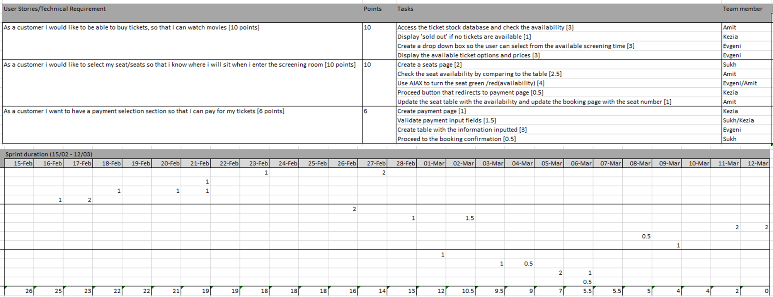

Figure : Sprint backlog 2

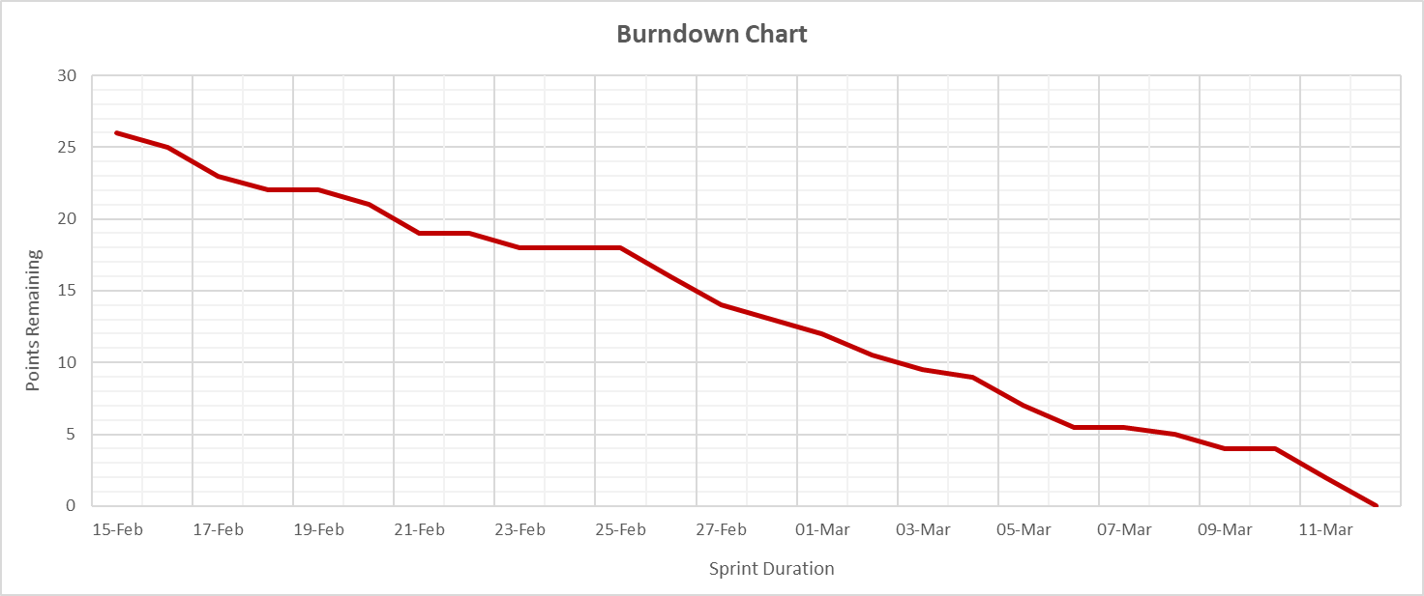

Figure : Burndown chart

Sprint Review

Upon completion of our first sprint as a group, we had a meeting to discuss the remaining tasks of our assignment. Since our first sprint, we have been meeting up more frequently and communicating more effectively. For everyone to keep in close contact, we made a group chat on Discord which is now used as the main platform for sharing specific information or date changes to our meetings. We achieved most of our goals including getting all our tasks done. There were some challenges that we faced during the sprint which included some minor coding errors but those were resolved quickly.

During our second sprint, we came across some issues with our SQL tables. Upon inspection we found that we have a pair of tables that had very similar information, thus making one of them redundant. As such, we attempted to remove the table formerly known as ‘Ticket’, however, we found that the drop operation would not remove the table for us. After conducting research on this matter and discussing it with one of our lecturers, we discovered that we had to remove the foreign key constraints that were present in the other tables, by doing so we were able to drop the redundant table.

From this we learnt that it would be better to construct the tables as we go, that way we have a clear understanding of the contents that need to be within the table, how role the table plays, and it allows us to avoid any other redundancies. These were the main changes that were made during our second sprint.

One of our major tasks was to use Ajax and jQuery inside the cinema seat page so that when a client clicks on a specific seat it would turn green or red depending on the availability. In the beginning, it took us some time to refamiliarize with the material studied in the first semester, so we collectively read through past lectures.

At the end of Sprint 2, around the time that the Checkout page was completed, we decided to switch to Bootstrap which is a lightweight customisable framework to be able to do CSS more efficiently. Previously we had issues with aligning properties and as a result of using Bootstrap, we were able to prevent those issues to occur in the future.

Sprint Retrospective

The communication aspect of our group for this sprint has been much stronger than in the previous one. We have been setting up regular meetings to discuss our current state of progression and helping each other if a group member needs assistance for a task. The difference between communication at the beginning of the project and communication in sprint 2 is that now we are much more open with each other when it comes to asking for help on a task whereas, in the previous sprint, we tried to fix the issues we faced by ourselves.

Furthermore, one technique that we started using more often in this sprint was pair programming when completing the programming tasks that we assigned to ourselves in our scrum documentation. This method enabled us to be more time-efficient when working on tasks.  Moreover, it allowed us to gain insight into different methods that could be used when coding a specific part of our website.

We also began to update the burndown chart as we are doing the code instead of pre-planning it. This way the burndown chart obtained a more realistic representation by showing the period spent on each task.

Finally, we started to use a method called git branching allowing us to create a branch for a specific task. We split these tasks so that two members of the group would work together on a branch and then merge the changes back into the main branch.

Additionally, since we were given an extra week, we made a start on some of the tasks that will be presented in our third and final sprint such as the booking confirmation page for which we’ve set up the view and are working on the controller and mod